1-Mock API

🧪 What Is a Mock API?
# Source: AI Source: Provided by: [Data Path: Persons Table -> ID Column: 1, Name_En Column: Motasem Essam] -> From: [ChatGPT] on [1/19/2026]
A Mock API is a fake or simulated API that mimics the behavior of a real API. It’s used for testing, development, or prototyping when the actual backend is:
- Not ready yet ❌
- Too slow or unreliable 🌐
- Costly to call 💰
- Under development 🔧

🧠 In Simple Terms:
# Source: AI Source: Provided by: [Data Path: Persons Table -> ID Column: 1, Name_En Column: Motasem Essam] -> From: [ChatGPT] on [1/19/2026]
A Mock API pretends to be a real server by returning pre-defined responses to API calls.

🛠️ What Can You Do with a Mock API?
# Source: AI Source: Provided by: [Data Path: Persons Table -> ID Column: 1, Name_En Column: Motasem Essam] -> From: [ChatGPT] on [1/19/2026]
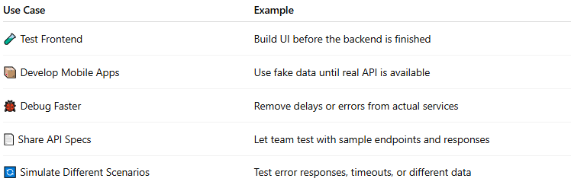

Use Case | Example
🧪 Test Frontend | Build UI before the backend is finished
📦 Develop Mobile Apps | Use fake data until real API is available
🐞 Debug Faster | Remove delays or errors from actual services
📄 Share API Specs | Let team test with sample endpoints and responses
🔄 Simulate Different Scenarios | Test error responses, timeouts, or different data

📦 Example
# Source: AI Source: Provided by: [Data Path: Persons Table -> ID Column: 1, Name_En Column: Motasem Essam] -> From: [ChatGPT] on [1/19/2026]
Say you plan to call this real API:
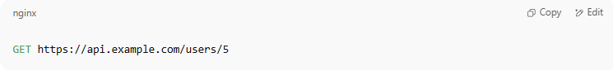
GET https://api.example.com/users/5

A mock API might simulate the same call and return:
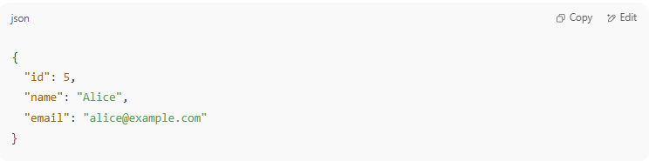
{
"id": 5,
"name": "Alice",
"email": "alice@example.com"
}

✅ Even though the data is fake, your frontend behaves like it's real.

🔧 How to Create a Mock API
# Source: AI Source: Provided by: [Data Path: Persons Table -> ID Column: 1, Name_En Column: Motasem Essam] -> From: [ChatGPT] on [1/19/2026]
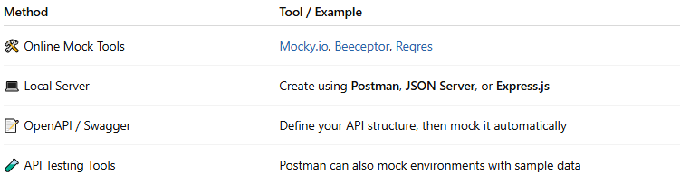

Method | Tool / Example
🛠 Online Mock Tools | Mocky.io, Beeceptor, Reqres
💻 Local Server | Create using Postman, JSON Server, or Express.js
📝 OpenAPI / Swagger | Define your API structure, then mock it automatically
🧪 API Testing Tools | Postman can also mock environments with sample data

📊 Mock API vs Real API
# Source: AI Source: Provided by: [Data Path: Persons Table -> ID Column: 1, Name_En Column: Motasem Essam] -> From: [ChatGPT] on [1/19/2026]
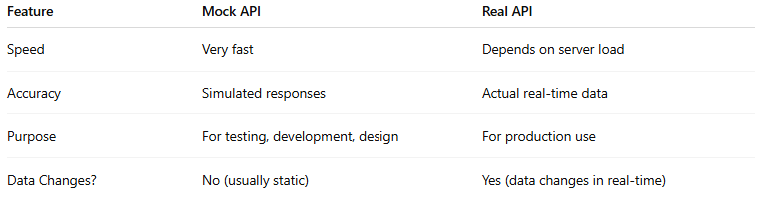

Feature | Mock API | Real API
Speed | Very fast | Depends on server load
Accuracy | Simulated responses | Actual real-time data
Purpose | For testing, development, design | For production use
Data Changes? | No (usually static) | Yes (data changes in real-time)

✅ When to Use a Mock API
# Source: AI Source: Provided by: [Data Path: Persons Table -> ID Column: 1, Name_En Column: Motasem Essam] -> From: [ChatGPT] on [1/19/2026]
- Backend isn’t ready
- Testing failure conditions or edge cases
- Working in offline or isolated environments
- Rapid frontend or mobile app development

JSON Server

🗂️ What Is JSON Server?
# Source: AI Source: Provided by: [Data Path: Persons Table -> ID Column: 1, Name_En Column: Motasem Essam] -> From: [ChatGPT] on [1/19/2026]
JSON Server is a lightweight fake REST API built from a simple JSON file. It allows you to:
- 🧪 Quickly mock a backend API
- 🖥️ Serve fake data from a local JSON file
- 🚀 Test or prototype your frontend without needing a real server

🧠 In Simple Terms:
# Source: AI Source: Provided by: [Data Path: Persons Table -> ID Column: 1, Name_En Column: Motasem Essam] -> From: [ChatGPT] on [1/19/2026]
JSON Server lets you create a full fake REST API in 30 seconds using just a .json file.

🔧 Why Use JSON Server?
# Source: AI Source: Provided by: [Data Path: Persons Table -> ID Column: 1, Name_En Column: Motasem Essam] -> From: [ChatGPT] on [1/19/2026]
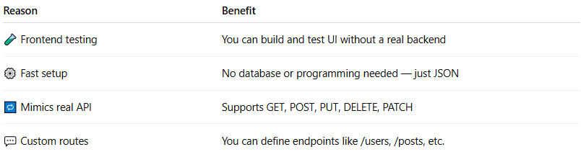
Reason | Benefit
🧪 Frontend testing | You can build and test UI without a real backend
⚙️ Fast setup | No database or programming needed — just JSON
🔁 Mimics real API | Supports GET, POST, PUT, DELETE, PATCH
💬 Custom routes | You can define endpoints like /users, /posts, etc.

🛠️ Example
# Source: AI Source: Provided by: [Data Path: Persons Table -> ID Column: 1, Name_En Column: Motasem Essam] -> From: [ChatGPT] on [1/19/2026]
1. Your db.json file:
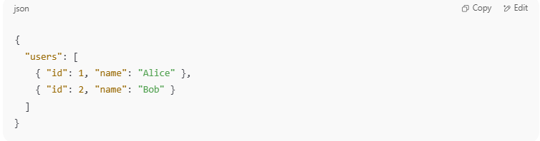

{
"users": [
{ "id": 1, "name": "Alice" },
{ "id": 2, "name": "Bob" }
]
}

2. Start the server:
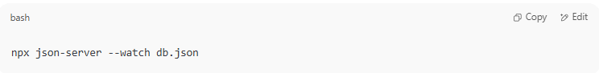
npx json-server --watch db.json

3. You now have a working REST API:
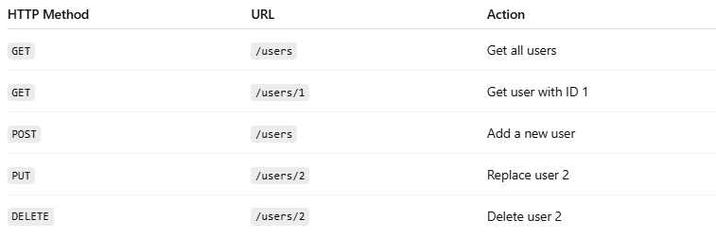

HTTP Method | URL | Action
GET | /users | Get all users
GET | /users/1 | Get user with ID 1
POST | /users | Add a new user
PUT | /users/2 | Replace user 2
DELETE | /users/2 | Delete user 2
✔️ All this happens without any backend code.

📦 Installation
# Source: AI Source: Provided by: [Data Path: Persons Table -> ID Column: 1, Name_En Column: Motasem Essam] -> From: [ChatGPT] on [1/19/2026]
If you have Node.js installed:
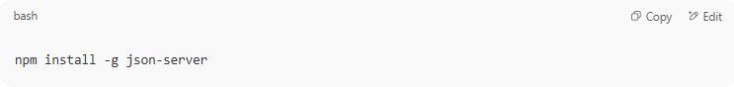
npm install -g json-server

Or use it without installing:
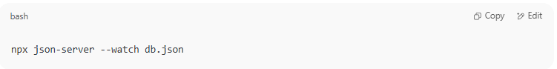
npx json-server --watch db.json

🧩 Features
# Source: AI Source: Provided by: [Data Path: Persons Table -> ID Column: 1, Name_En Column: Motasem Essam] -> From: [ChatGPT] on [1/19/2026]
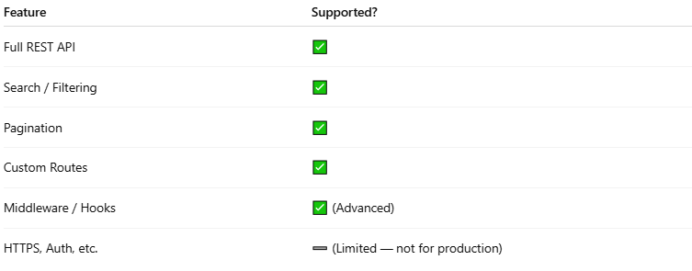

Feature | Supported?
Full REST API | ✅
Search / Filtering | ✅
Pagination | ✅
Custom Routes | ✅
Middleware / Hooks | ✅ (Advanced)
HTTPS, Auth, etc. | ➖ (Limited — not for production)

🧠 Summary
# Source: AI Source: Provided by: [Data Path: Persons Table -> ID Column: 1, Name_En Column: Motasem Essam] -> From: [ChatGPT] on [1/19/2026]
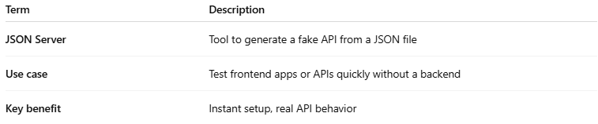
Term | Description
JSON Server | Tool to generate a fake API from a JSON file
Use case | Test frontend apps or APIs quickly without a backend
Key benefit | Instant setup, real API behavior

create a Mock API.
# Source: AI Source: Provided by: [Data Path: Persons Table -> ID Column: 1, Name_En Column: Motasem Essam] -> From: [ChatGPT] on [1/19/2026]
Awesome! Let's go step-by-step and learn how to create a Mock API.
I’ll show you two simple ways:

✅ OPTION 1: Using Postman (No Code)
# Source: AI Source: Provided by: [Data Path: Persons Table -> ID Column: 1, Name_En Column: Motasem Essam] -> From: [ChatGPT] on [1/19/2026]
🛠 Postman Mock Server
- Open Postman (app or web)
- Click ➕ "New" > "Mock Server"
- Choose:
  - Create a new request (you define endpoints manually)
  - OR use an existing collection of API requests
- Enter example request and response:
  - Method: GET
  - URL: /users/5
  - Response:
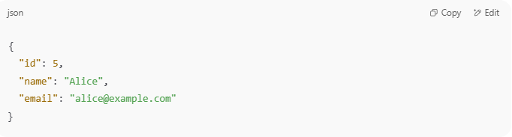
{
"id": 5,
"name": "Alice",
"email": "alice@example.com"
}

- Click "Create Mock Server"
- Postman gives you a public URL like:
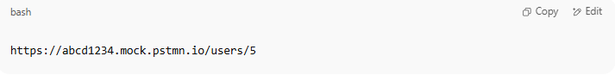
https://abcd1234.mock.pstmn.io/users/5
- 🎯 You can now send requests to this fake URL — Postman returns your sample data.

✅ OPTION 2: Using JSON Server (Local, With Code)

🧱 JSON Server (Node.js-based tool)

🖥 Requirements:
# Source: AI Source: Provided by: [Data Path: Persons Table -> ID Column: 1, Name_En Column: Motasem Essam] -> From: [ChatGPT] on [1/19/2026]
- Node.js installed
- Terminal (Command Prompt or Bash)

📦 Step-by-step:
# Source: AI Source: Provided by: [Data Path: Persons Table -> ID Column: 1, Name_En Column: Motasem Essam] -> From: [ChatGPT] on [1/19/2026]
- Install JSON Server:

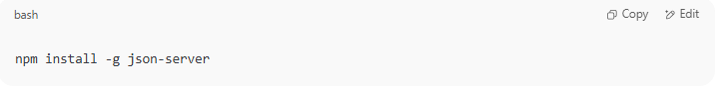
npm install -g json-server

- Create a file db.json with fake data:
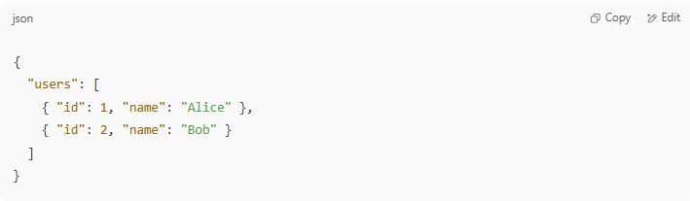
{
"users": [
{ "id": 1, "name": "Alice" },
{ "id": 2, "name": "Bob" }
]
}

- Run the server:
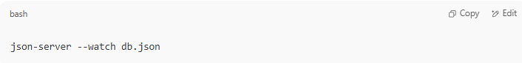
json-server --watch db.json

- Your mock API is now running at:
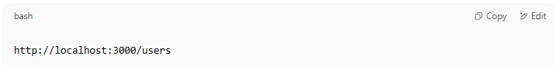
http://localhost:3000/users
- Example calls:
  - GET /users → list of users
  - GET /users/1 → single user
  - POST /users → add user
  - PUT /users/1 → update user
✅ JSON Server supports full CRUD operations — just like a real REST API.

🧠 Summary
# Source: AI Source: Provided by: [Data Path: Persons Table -> ID Column: 1, Name_En Column: Motasem Essam] -> From: [ChatGPT] on [1/19/2026]
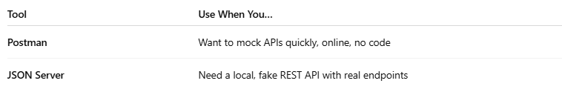
Tool | Use When You…
Postman | Want to mock APIs quickly, online, no code
JSON Server | Need a local, fake REST API with real endpoints

🧠 Summary
# Source: AI Source: Provided by: [Data Path: Persons Table -> ID Column: 1, Name_En Column: Motasem Essam] -> From: [ChatGPT] on [1/19/2026]
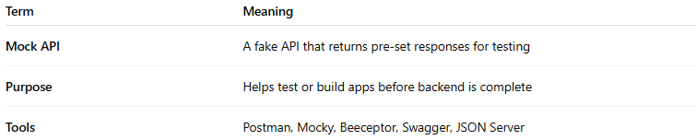

Term | Meaning
Mock API | A fake API that returns pre-set responses for testing
Purpose | Helps test or build apps before backend is complete
Tools | Postman, Mocky, Beeceptor, Swagger, JSON Server

